Change from single user mode to multi-user

Check your current Application Path (the folder for data storage)

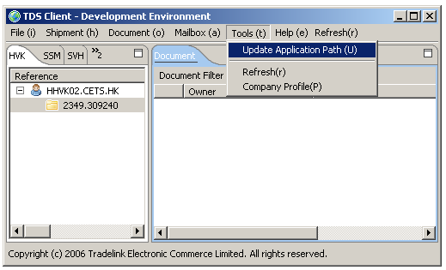

For single user mode, the most common path is C:\Documents and Settings\<user>\.tradelink

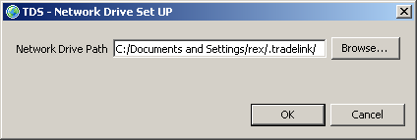

Quit TDS Client, and copy the data files and folder here

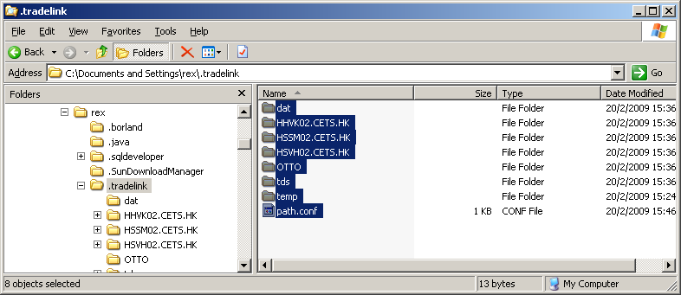

Create a share folder in the server PC, in this example, H: drive is created for shared data storage (You can use sub-folder, just make sure all client PCs can write to that folder)

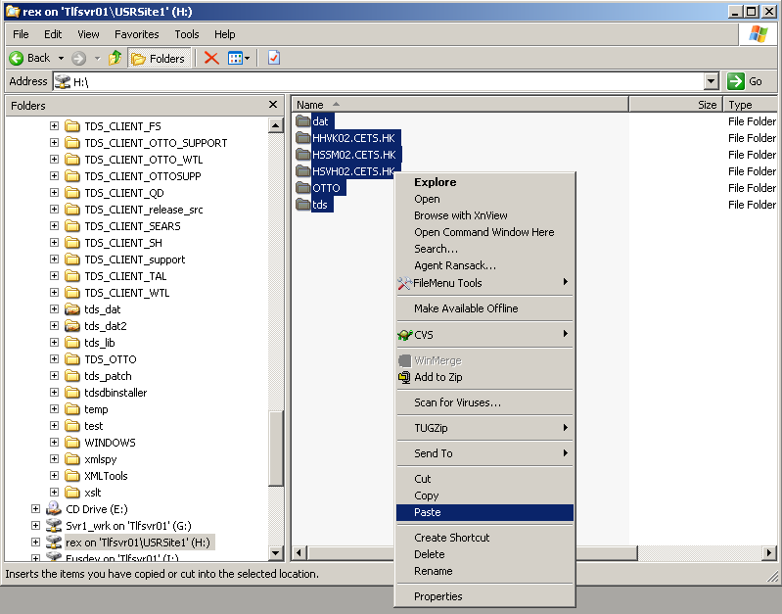

Start TDS Client, set the Application Path to the shared folder

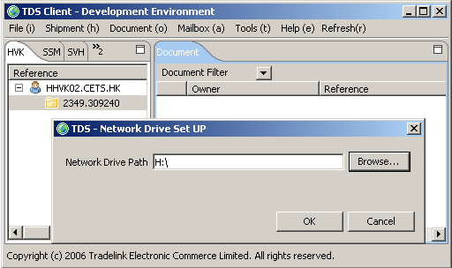

System will quit

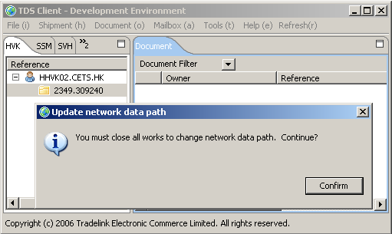

Install and start TDS Client in the server PC.
Change the Application Path to the shared folder, and then confirm all data are there

MS SQL Server installation plus data conversion

Step1.
Unzip the installation.zip then below hierarchy will be shown.
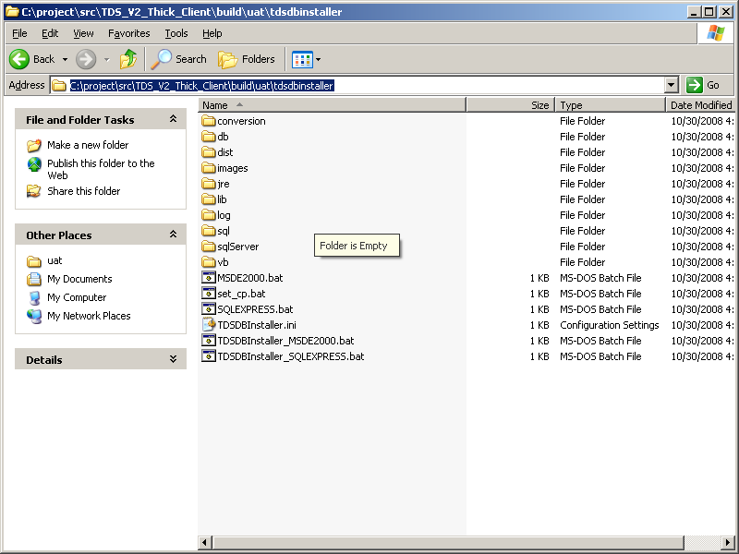

If install SQL Express 2005, double click on SQLEXPRESS.bat.
If install MSDE 2000, double click on MSDE2000.bat.

Step 2
TDS SQL Server installation dialog show, total 3 items available for selection.

- Install database server
  - Install TDS database instance.
  - If firstly install TDS database, this option is required
- Create database schema
  - Create TDS database schema
  - If firstly install TDS database, this option is required.
- Migrate data
  - Migrate existing TDS record to new TDS database
  - If an old TDS version being used, and the records should be remained, this option is required.

MSDE 2000 being selected
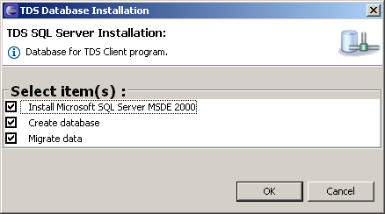

SQL Express 2005 being selected
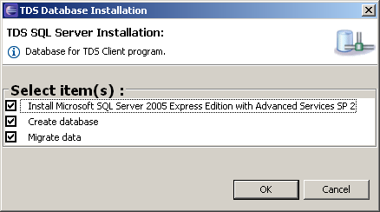
Step 3
If Install database server option (1st option) being selected, the corresponding database service will be installed automatically.

MSDE 2000 being selected
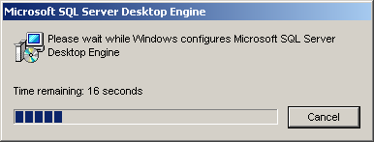

SQL Express 2005 being selected
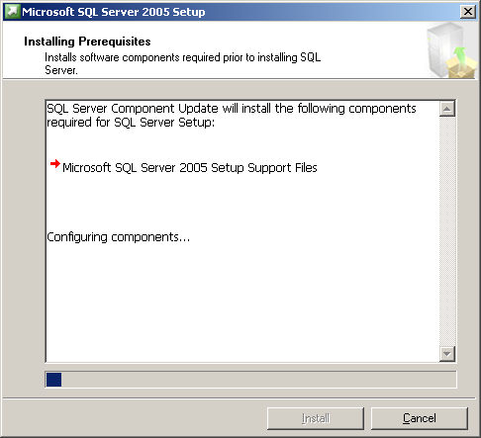

Step 4
If Create database option (2nd option) being selected, TDS database schema will be created automatically.

Step 5
If Migrate data option (3rd option) being selected, Data migration program will migrate the record from old data store to newly installed database server (MSDE2000/SQL Express 2005)

Step 6
Installation completed message will be shown if all selected item(s) completed.

